

## Topic: Icons for Document Types

Each document type in theSource has a designated icon and color. Learn how to leverage these icons to find what you are looking for more quickly.

If you get a lot of search results but you know you need to find a work instruction you can quickly scan for a red icon!

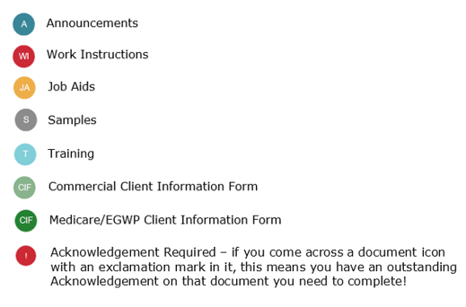

 Your next challenge on the quest to becoming a Certified theSource Wizard is to search for a topic and scan the results for the icon color that corresponds with the document you are searching for.

Not to Be Reproduced or Disclosed to Others without Prior Written Approval

**ELECTRONIC DATA = OFFICIAL VERSION / PAPER COPY = INFORMATIONAL ONLY**